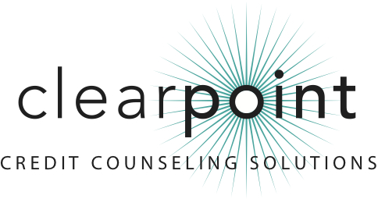

FOR MORE INFORMATION:
Bruce McClary | 877-877-1995 ext. 2730 | bruce.mcclary@ClearPointCCS.org
1-877-877-1995 | www.ClearPointCCS.org

Consul David Figueroa Ortega Honored by ClearPoint Credit Counseling Solutions

December 4, 2012 (Los Angeles, CA) – David Figueroa Ortega, general consul of the Mexican Consulate in Los Angeles, has been selected to receive the 2012 Petzall Community Service Award by ClearPoint Credit Counseling Solutions.
Consul Figueroa was instrumental in the first Memorandum of Understanding (MOU) between a Mexican Consulate and ClearPoint. Since that initial agreement in 2011, ClearPoint has formalized similar relationships with 11 Mexican Consulates nationwide, opening doors for the nonprofit agency to conduct outreach, education and on-site counseling to Mexican communities.
The Petzall Community Service Award is presented annually to an individual who advocates independently for ClearPoint’s mission of consumer health through financial education. The award’s namesake, Gerhard J. Petzall, is a distinguished member of the legal profession and a military veteran. He also served on ClearPoint’s board of directors for more than 30 years.
ClearPoint is a member of the National Foundation for Credit Counseling (NFCC), a system-wide accredited business with the Council on Better Business Bureaus, and a Housing and Urban Development (HUD)-approved housing counseling agency.
For more information, visit ClearPoint at http://www.clearpointccs.org or call 877.877.1995.

###

