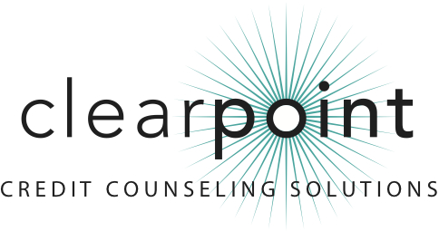
FOR MORE INFORMATION:
Bruce McClary | 877-877-1995 ext. 2730 | bruce.mcclary@ClearPointCCS.org
1-877-877-1995 | www.ClearPointCCS.org

Sevag Tateosian Honored by ClearPoint Credit Counseling Solutions

December 4, 2012 (Fresno, CA) – Sevag Tateosian of the United Way of Fresno County has been presented with the 2012 Howle Community Support Award by ClearPoint Credit Counseling Solutions.
As a member of ClearPoint’s Regional Advisory Committee, Tateosian has been a vocal advocate for ClearPoint in the community. He has recruited two new committee members, consistently offers new ideas on how ClearPoint can better serve the community and is a reliable source of both information and introductions to prospective partners. In particular, Tateosian has been instrumental in promoting ClearPoint through United Way’s SparkPoint one-stop financial help and education centers, the 2-1-1 Fresno County initiative offering round-the-clock connection to community resources, and the Bank on Fresno coalition formed to provide residents with greater access to mainstream financial institutions.
The Howle Community Support Award honors a ClearPoint Regional Advisory Committee member for advancing the nonprofit agency’s mission of consumer health through financial education. The award’s namesake, Paul W. Howle III, is an innovator in the field of nonprofit credit counseling and served on ClearPoint’s Board of Directors for more than three decades.
ClearPoint is a member of the National Foundation for Credit Counseling (NFCC), a system-wide accredited business with the Council on Better Business Bureaus, and a Housing and Urban Development (HUD)-approved housing counseling agency.
For more information, visit ClearPoint at http://www.clearpointccs.org or call 877.877.1995.

###

